**Crop Prediction Using Machine Learning**

Screen Shot

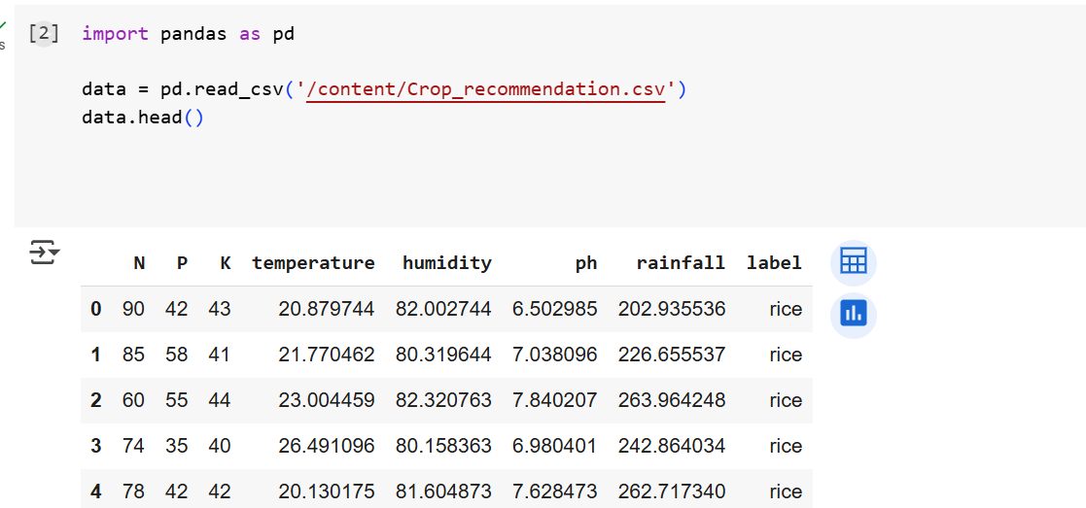Data Set

Accuracy

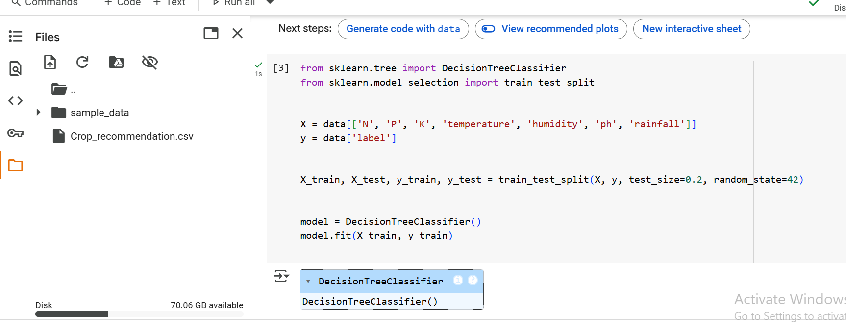

Accuracy on Test Data

